Old Windsor Parish Council Planning Addendum

APPLICATIONS TO BE CONSIDERED AT THE MEETING HELD ON
WEDNESDAY 12th FEBRUARY 2025
APPLICATIONS

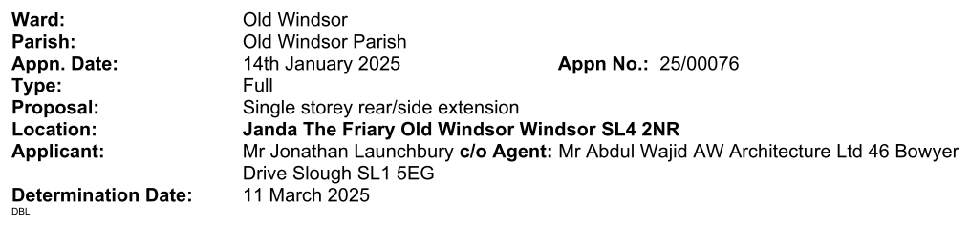

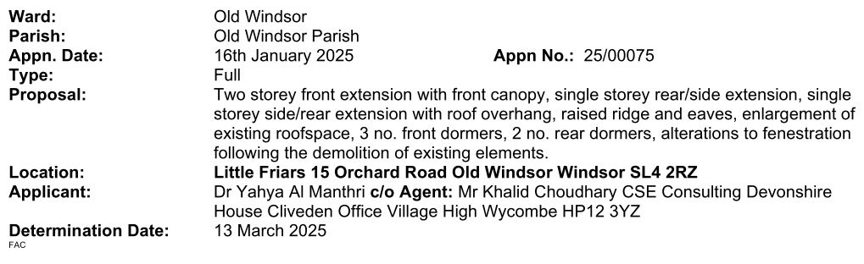

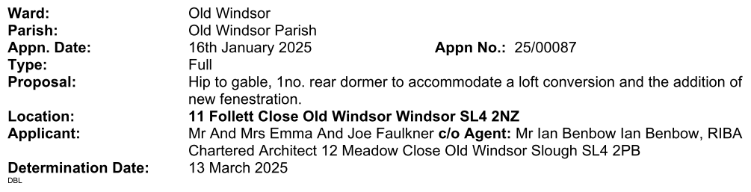

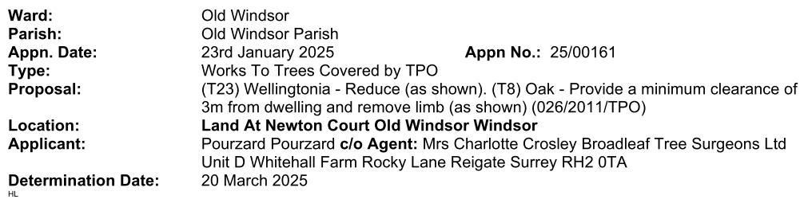

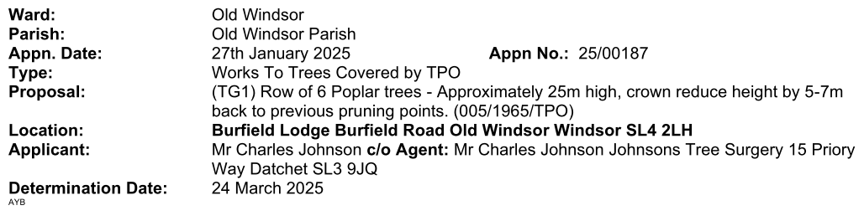

Appn. Date: | 27 January 2025 | Appn. No.: | 25/00136
Type: | Full
Proposal: | Single storey front extension
Location: | Roseland Dry Cleaners 2 Wheatsheaf Parade St Lukes Road Old Windsor Windsor SL4 2QH
Parish/Ward: | Old Windsor Parish/Old Windsor
Applicant: | Mr A Aksahin
Agent: | Mr Sinan Ay Sayar Design 14 Marsh Close Waltham Cross EN8 7JF email: mimarsinan_ay@hotmail.com tel: 07887871149

Appn. Date: | 3 February 2025 | Appn. No.: | 24/03086
Type: | Variation Under Reg 73
Proposal: | Variation (under Section 73a) of Condition 2 to substitute those plans approved under 21/00825/FULL (Allowed on Appeal) for the conversion of the existing Public House to include a single storey front/side extension, new front canopy, single storey side/rear extension, new external finish, alterations to fenestration, associate parking, bin and cycle storage and landscaping following demolition of the single storey side/rear extensions to provide 2no. semi detached dwellings and 1no. detached dwelling with amended plans.
Location: | Jolly Gardener 92 To 94 St Lukes Road And Land At 92 To 94 St Lukes Road Old Windsor Windsor
Parish/Ward: | Old Windsor Parish/Old Windsor
Applicant: | Mr Shailender Nagpal
Agent: | Mr Shailender Nagpal Design And Plan Consultants Ltd 93 Cotmandene Crescent Orpington Kent BR5 2RA email: info@dapconsultants.co.uk tel: 07931931035

THE PARISH COUNCIL URGES RESIDENTS WHO HAVE STRONG FEELINGS FOR OR AGAINST ANY PLANNING APPLICATION TO MAKE REPRESENTATIONS TO RBWM WHO MAKE THE FINAL DECISION ON ALL PLANNING APPLICATIONS HOWEVER THE ATTENDANCE OF RESIDENTS AND RECEIPT OF THEIR COMMENTS IS PARTICULARLY WELCOMED BY THE PARISH COUNCIL

